**Devops**

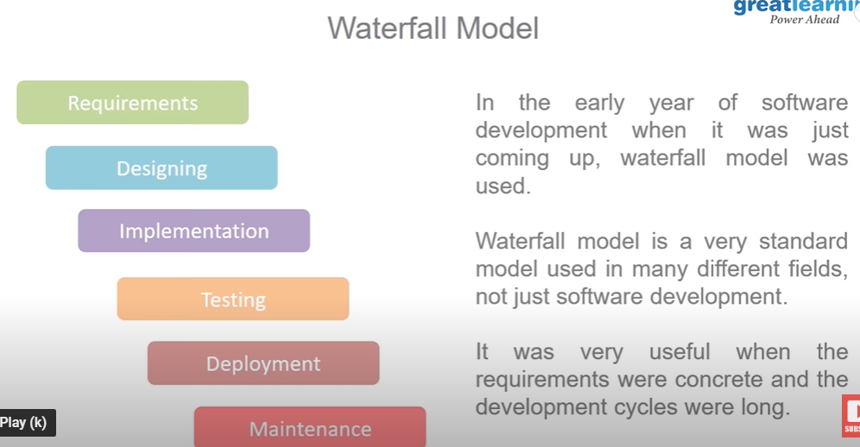Concrete requirements means: Hospital Software, POS etc.

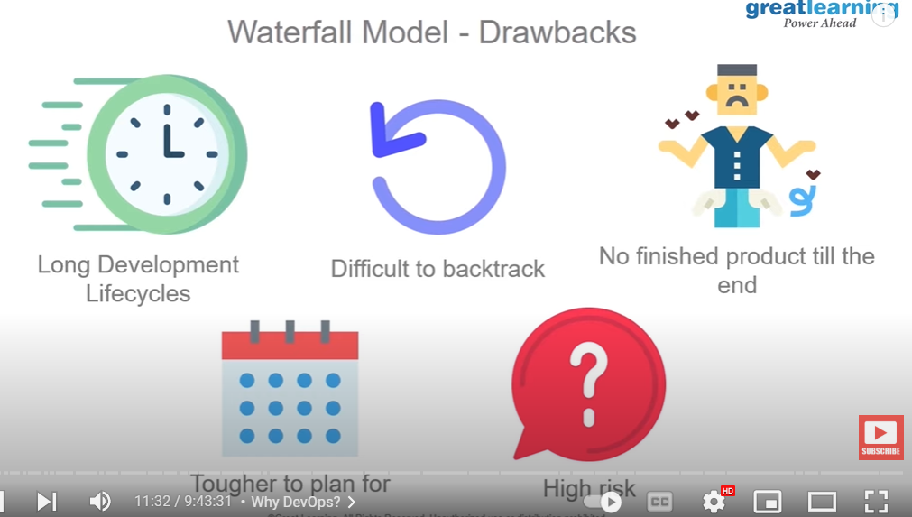

If you are building single player game, then you can use waterfall model because you know the end product.

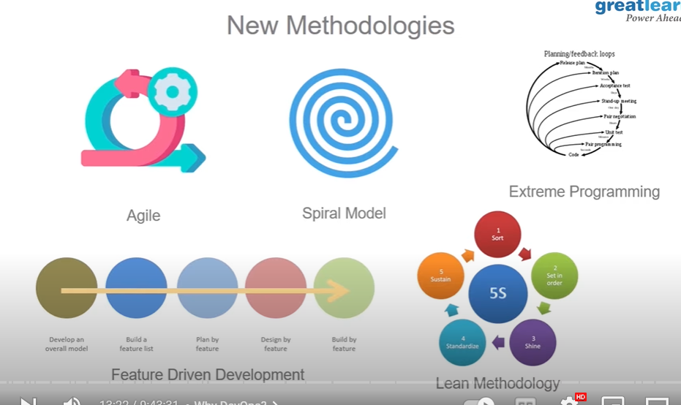

These methodologies are much better than waterfall model.

What is Agile vs DevOps?

DevOps is a culture, fostering collaboration amongst all participants involved in the development and maintenance of software. Agile can be described as a development methodology designed to maintain productivity and drive releases with the common reality of changing needs.

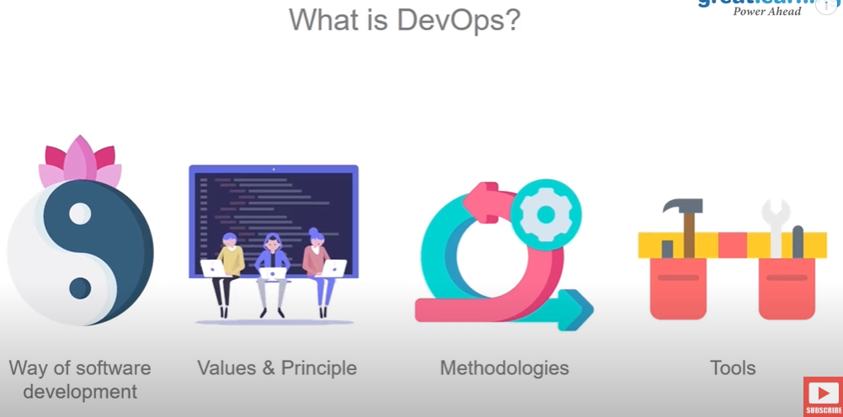

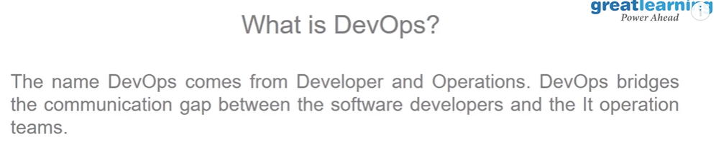

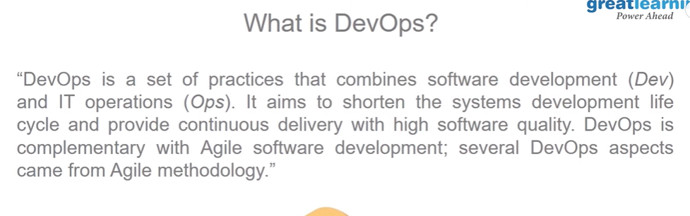

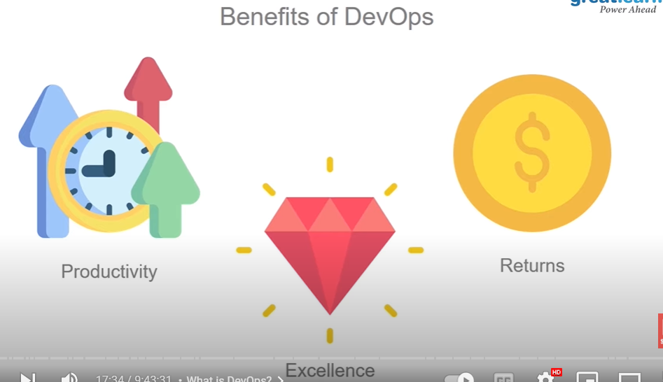

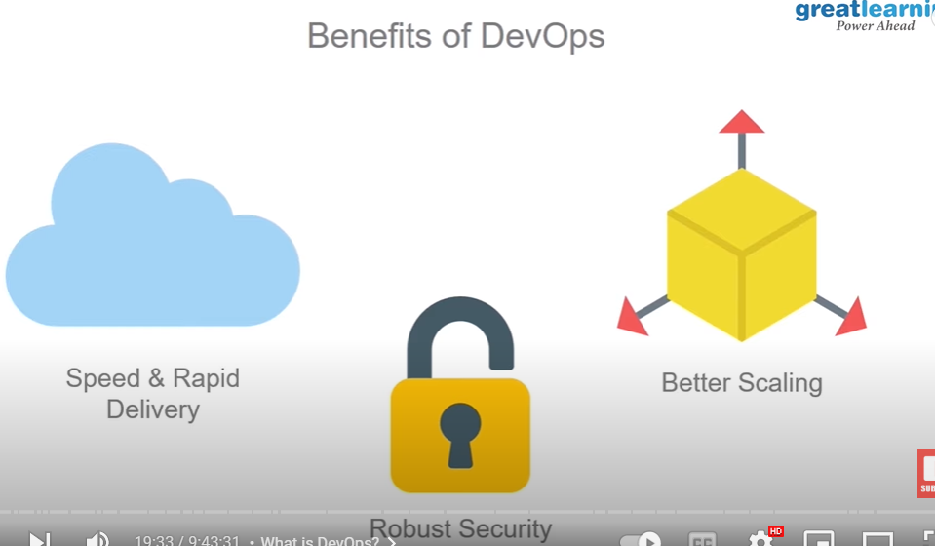

In devops security is also important. Furthermore, one separate field lies in devops for security which name is SecDevops.

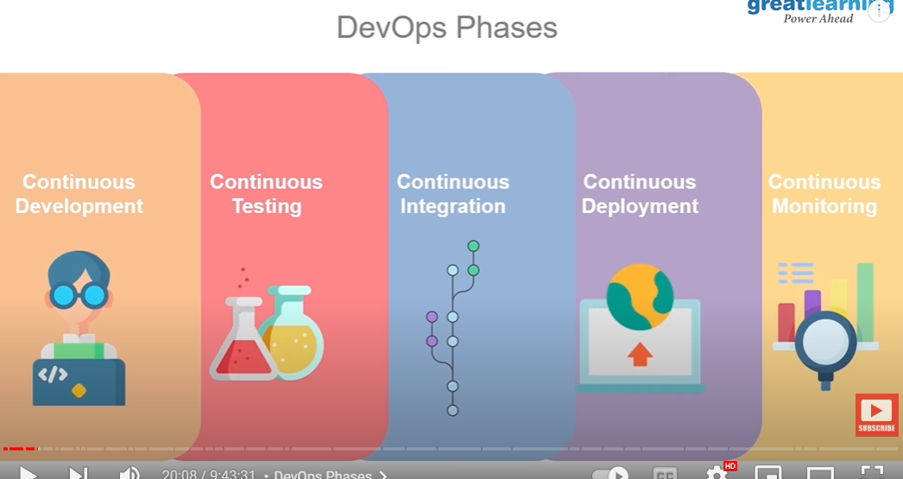

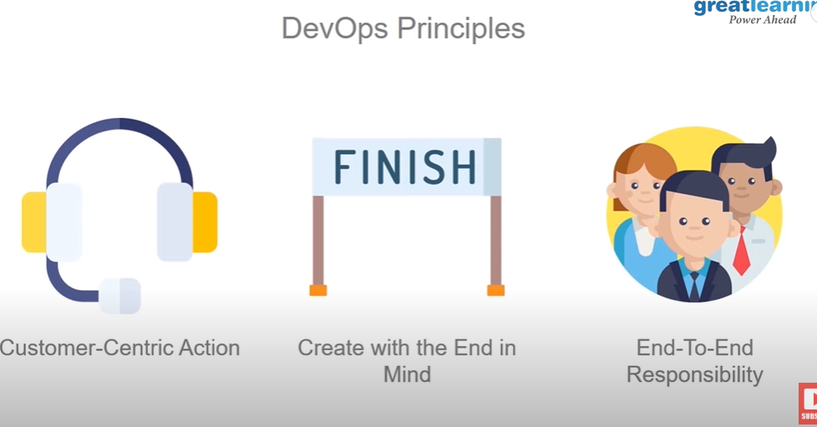

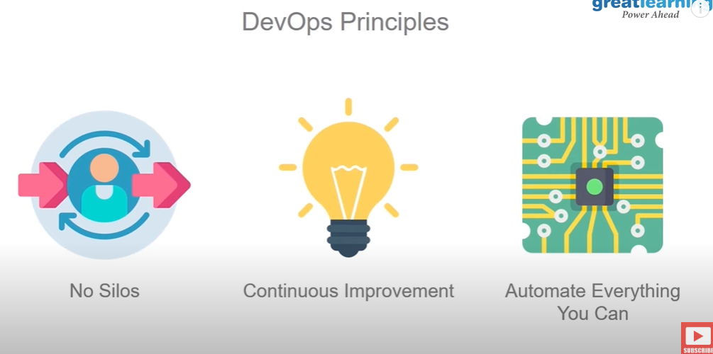

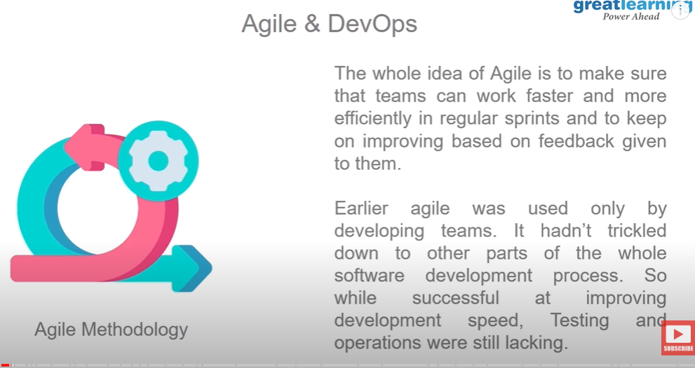

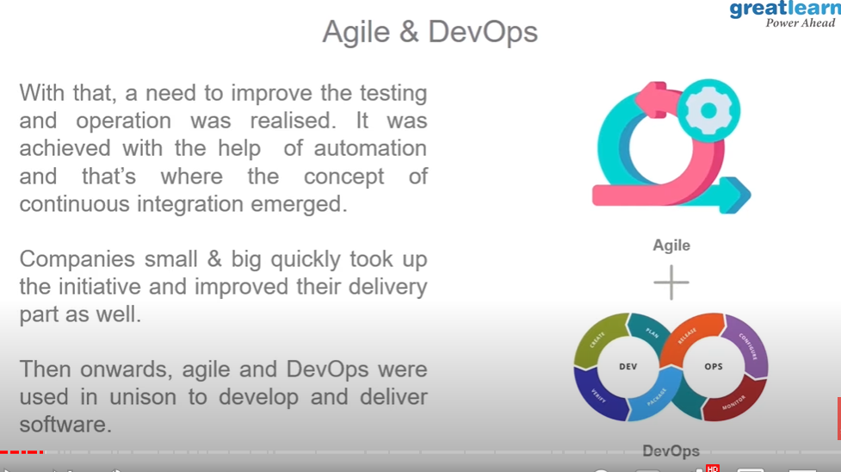

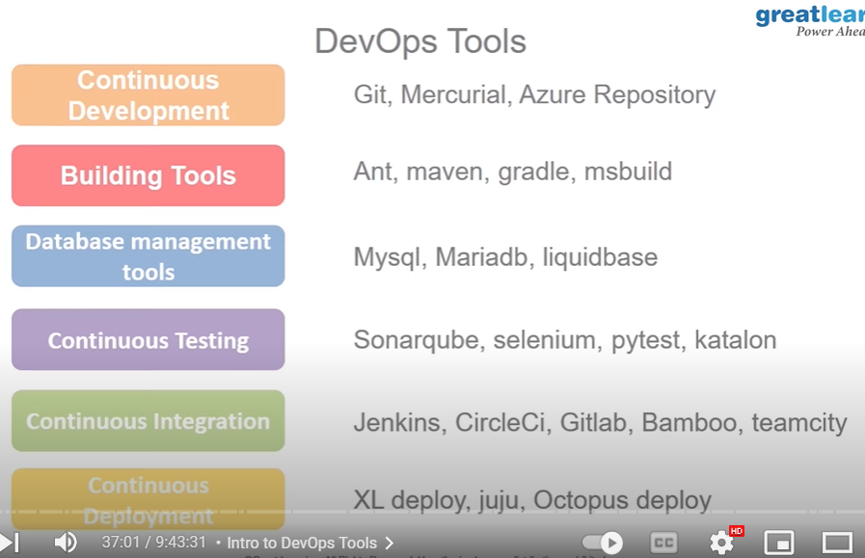

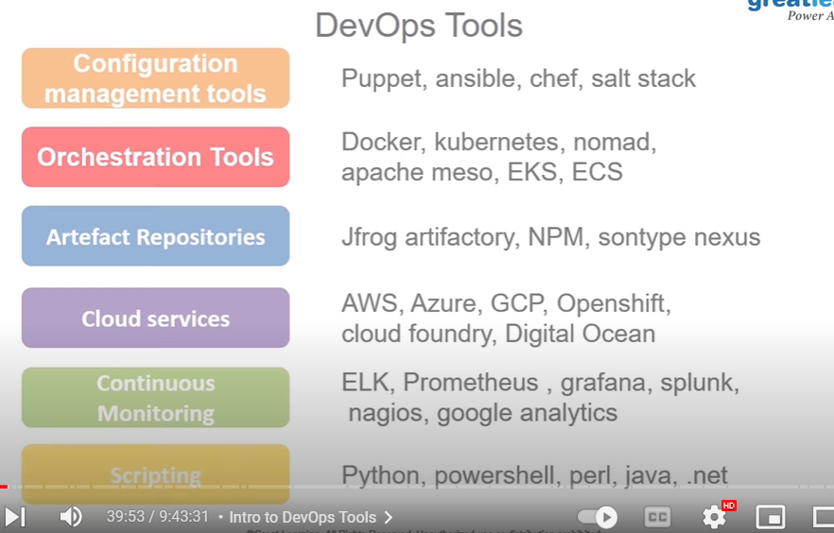

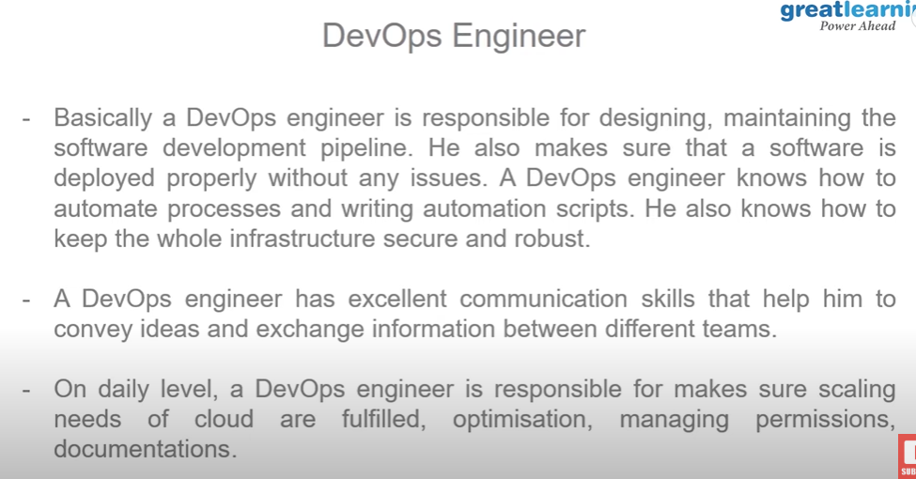

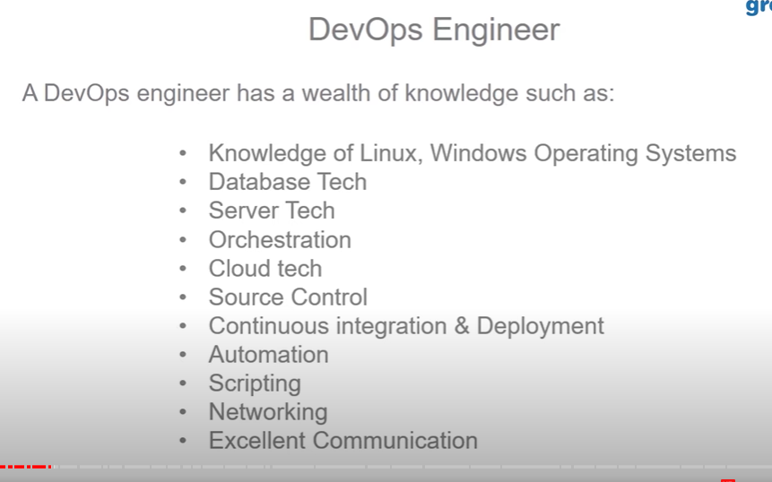

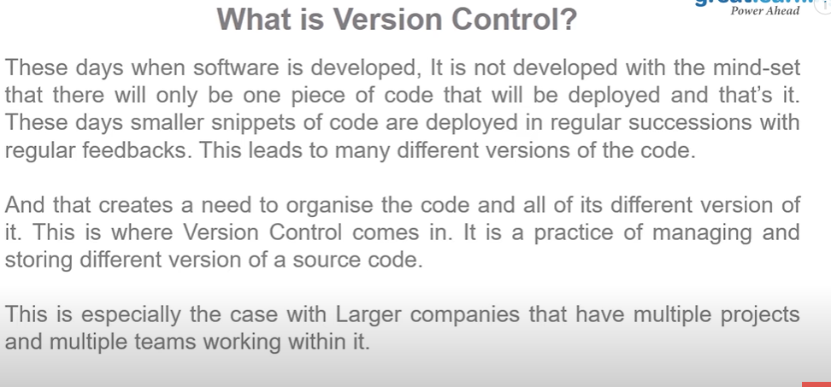

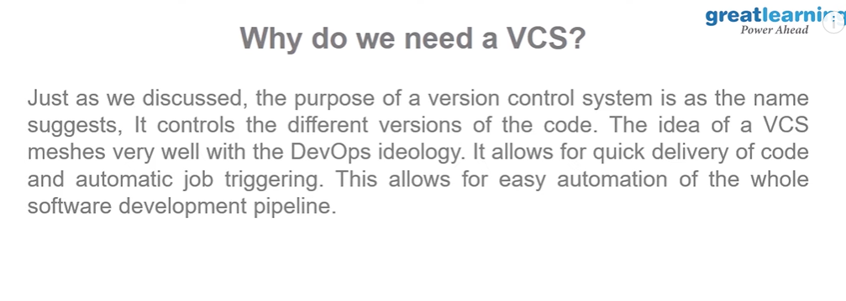

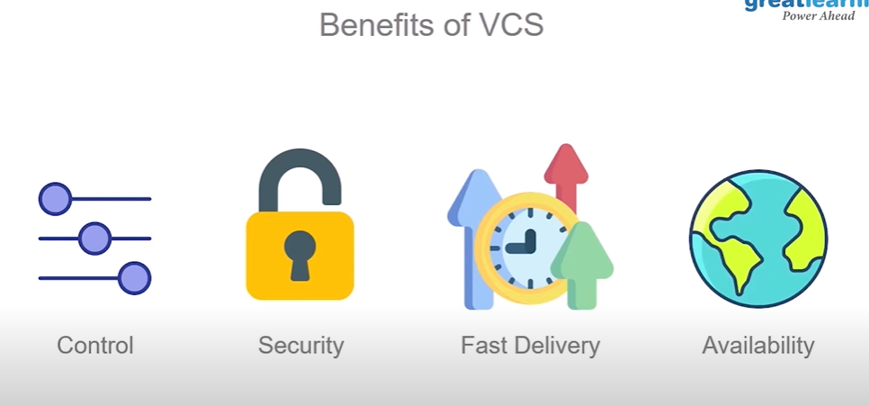

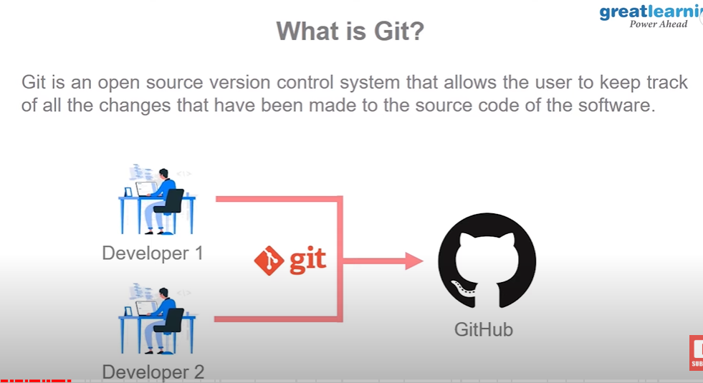

We can create Linux instance in AWS for practice.

Open the Amazon EC2 console at https://console.aws.amazon.com/ec2/ . Choose Launch Instance. In Step 1: Choose an Amazon Machine Image (AMI), find an Amazon Linux 2 AMI at the top of the list and choose Select. In Step 2: Choose an Instance Type, choose Next: Configure Instance Details.

First you need to update Ubuntu instance:

**Command: sudo apt update**

It will refresh the repository list.

Then you need to install sudo apt git.

**Command: sudo apt install git.**

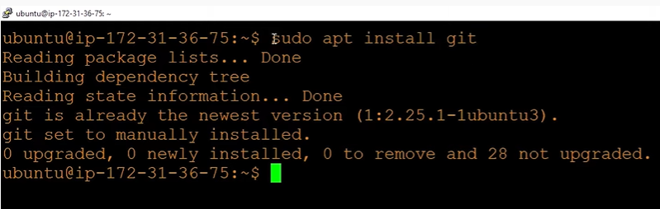

Now you’ll need to config git username and email in git cmd.

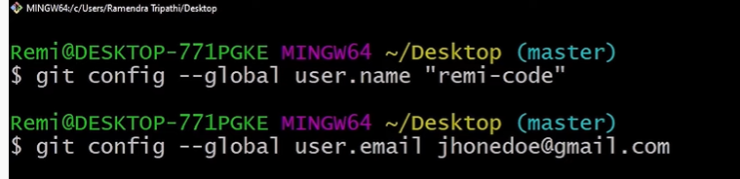

If you want to check did it configured or not?

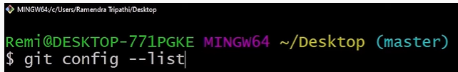

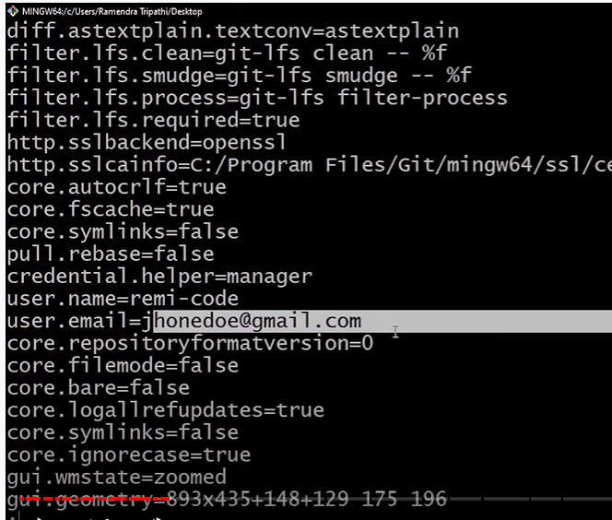

If you want to exit: CTRL+C

You can check directly:

~/.gitconfig command.

You can run same thing in Linux system.

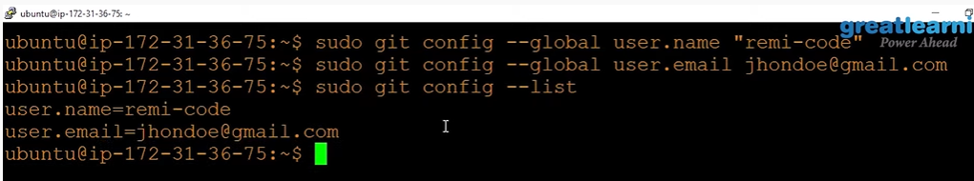

**GIT Basic Commands:**

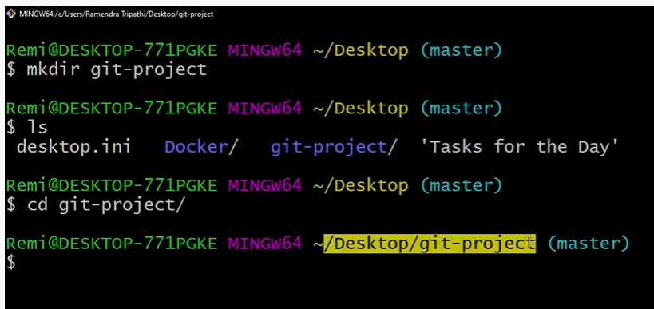

Now we need to add one project in git-project directory.

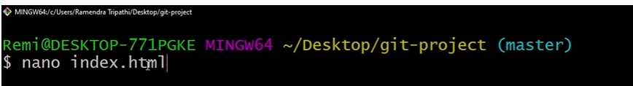

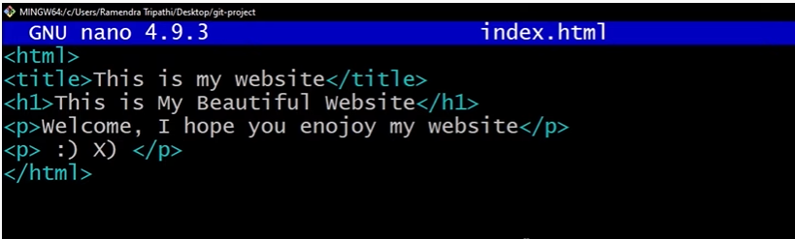

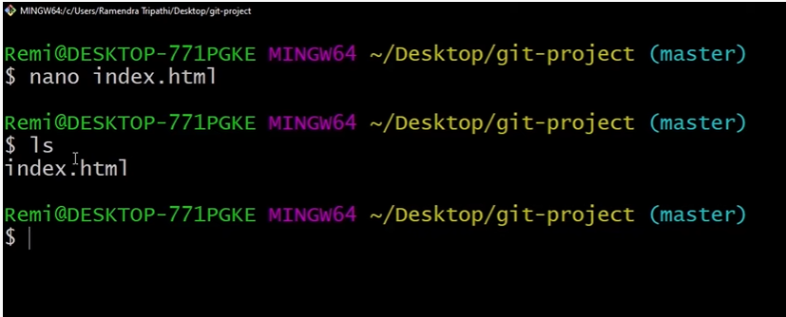

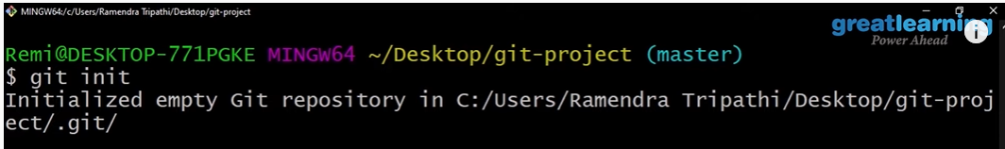

GIT initialize k baad staging Karengay us sai pehlay file mai kuch changes karlengay.

